# Smart Farmer - IOT Enabled Smart Farming Application

**Pre-Requisites (FAST2SMS)**

|  |  |
| --- | --- |
| **TITLE** | **Smart Farmer-IOT Enabled Smart Farming Application** |
| **DOMAIN NAME** | INTERNET OF THINGS |
| **TEAM ID** | PNT2022TMID41868 |

# Step 1:

Type fast2sms in google and click on the first link

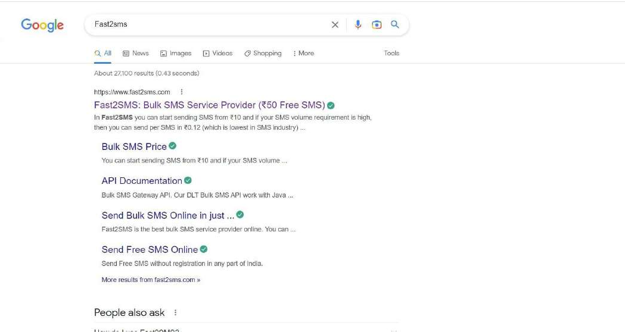

# Step 2:

Click on sign up now

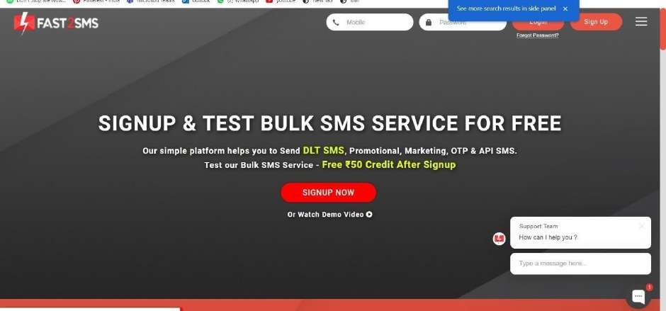

# Step 3:

Give your details and click on the check box, then click the submit button.

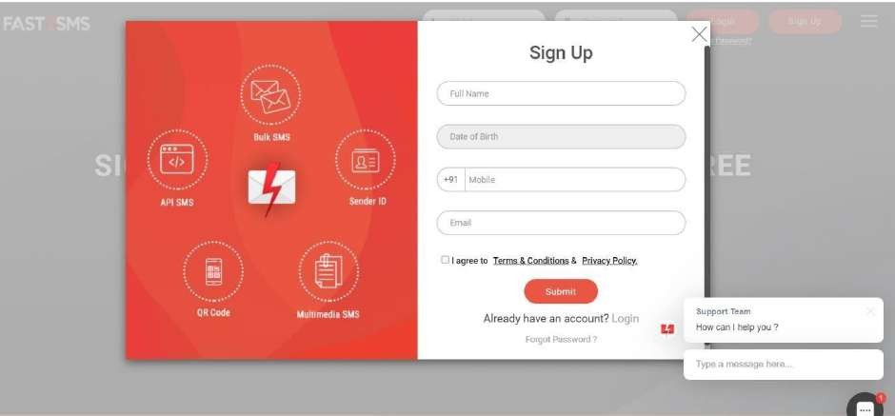

# Step 4:

You will get the SMS with your password. Type your mobile number and the password then click on the submit button.

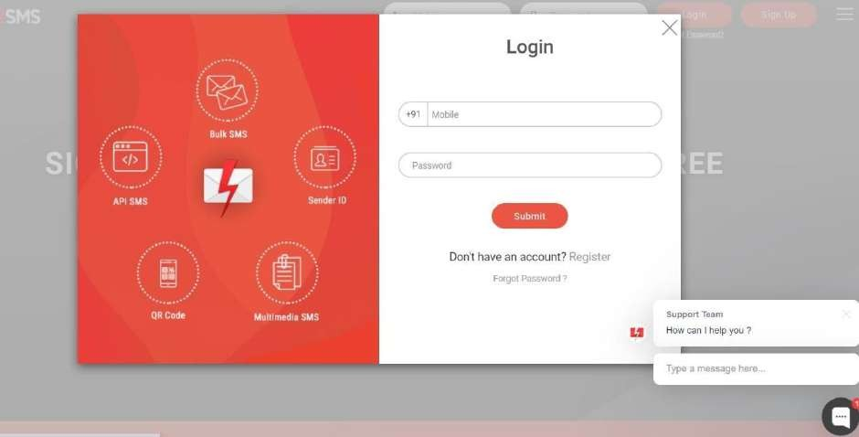

# Step 5:

Click on the Dev API

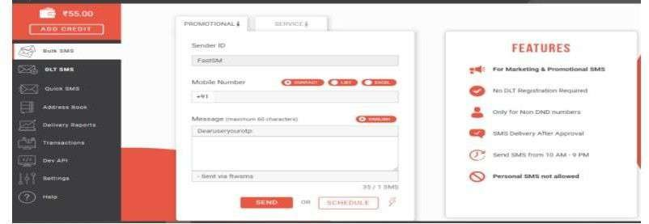

# Step 6:

Select the Route as Quick SMS and type the message in Message box.

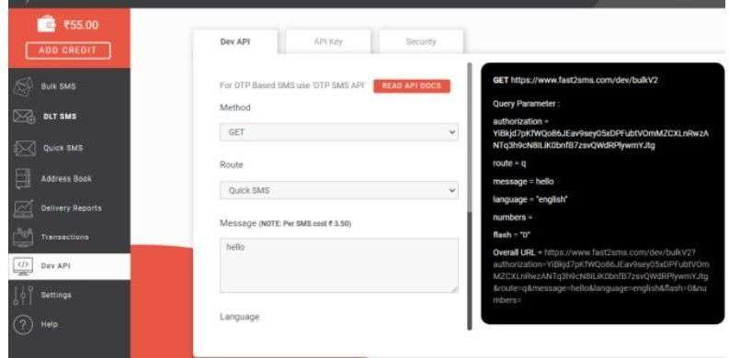

# Step 7:

Select your language and type your Mobile number in contact

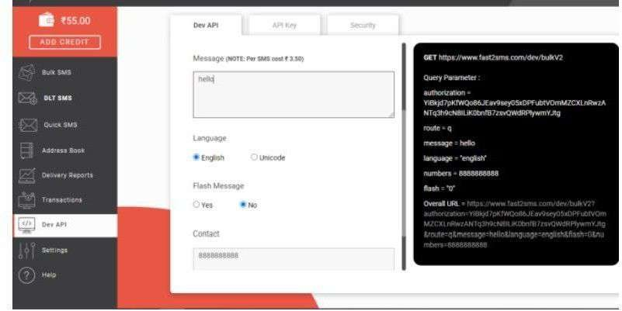

# Step 8:

Copy the URL and paste it in the new tab

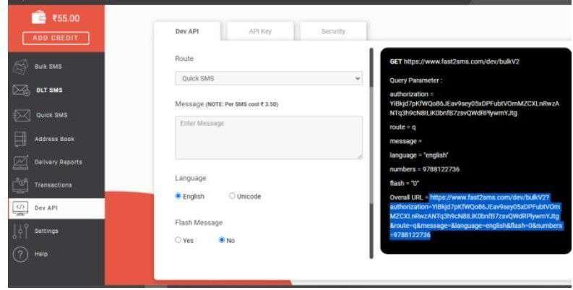

# Step 9:

You will get the SMS in the new tab

